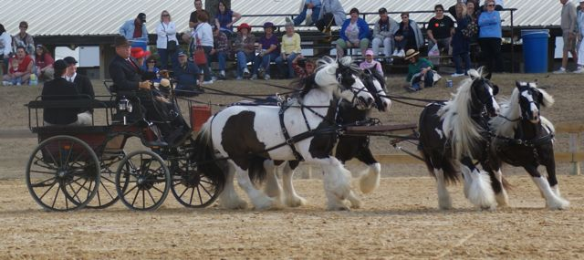
Event Name: Florida State Fair Driving Competitions
Event Date: February 7-8, 2009

4 Class: AD1 TURN OUT PAIRS/MULTIPLES
1 WR RANCH GypsyVanner Esmeralda,Jasmine,WR Pie,Vanilla Swirl

8 Class: AD15 WORKING PAIRS/MULTIPLES
1 WR RANCH GypsyVanner Esmeralda,Jasmine,WR Pie,Vanilla Swirl

12 Class: AD28 PROGRESSIVE OBSTACLES PAIRS/MULTIPLES
1 WR RANCH GypsyVanner Esmeralda,Jasmine,WR Pie,Vanilla Swirl

16 Class: AD23 ADT HAZARDS PAIRS/MULTIPLES

1 WR RANCH GypsyVanner Esmeralda,Jasmine,WR Pie,Vanilla Swirl
20 Class: AD19 PICK YOUR OWN ROUTE PAIRS/MULTIPLES

1 WR RANCH GypsyVanner Esmeralda,Jasmine,WR Pie,Vanilla Swirl

24 Class: AD4 REINSMANSHIP PAIRS/MULTIPLES
1 WR RANCH GypsyVanner Esmeralda,Jasmine,WR Pie,Vanilla Swirl

28 Class: AD12 ADT CONES PAIRS/MULTIPLES
1 WR RANCH GypsyVanner Esmeralda,Jasmine,WR Pie,Vanilla Swirl

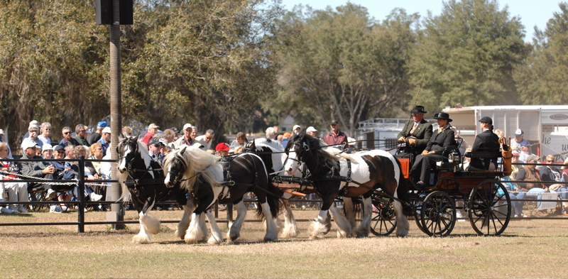

Event Name: 2009 Florida Horse Festival & Carriage Show
Event Date: February 20, 21 & 22, 2009

Division: Multiple Horse/Ponies

Class Name: (Turnout)
1ST . Giles, Bob Esmeralda, Jasmine, WR Pie, Vanilla Swirl

Class Name: (Reinsmanship)
2ND . Giles, Bob Esmeralda, Jasmine, WR Pie, Vanilla Swirl

Class Name: (Progressive Obstacles)
1ST . Giles, Bob Esmeralda, Jasmine, WR Pie, Vanilla Swirl

Class Name: (Cross Country)
2ND . Giles, Bob Esmeralda, Jasmine, WR Pie, Vanilla Swirl

Division Championship: Multiples Horse/Pony
2ND . Giles, Bob Esmeralda, Jasmine, WR Pie, Vanilla Swirl

Division: Gentlemen to Drive – Horses
4TH . Giles, Bob Esmeralda, Jasmine, WR Pie, Vanilla Swirl

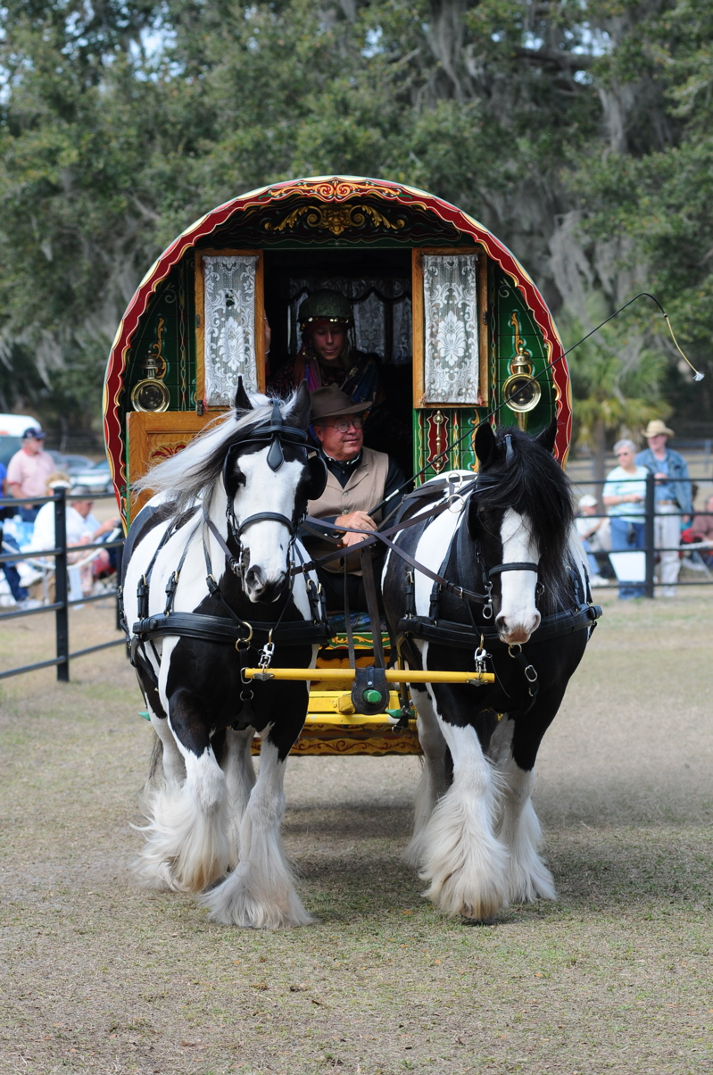

Event Name: 2009 Florida Horse Festival & Carriage Show
Event Date: February 20, 21 & 22, 2009

Division: Trade/Commercial

Class Name: (Turnout)
2ND . Giles, Bob Esmeralda, Jasmine

Class Name: (Working)
1st . Giles, Bob Esmeralda, Jasmine

Class Name: (Preformance)
2ND . Giles, Bob Esmeralda, Jasmine

Little Everglades Steeplechase
March, 8th

Four-in-hand Demo on race day (8000) in attendance voted best attraction in show

Esmeralda, Jasmine, WR Pie, Vanilla Swirl

Breed show Beaverdam farm Antigonish, Nova Scotia
July 2009

WR Pie and Vanilla Swirl as pair, single and tandem

Highland Parade Antigonish Nova Scotia
July 18th 2009
WR Pie and Vanilla Swirl as pair,

Christmas at Canterbury, Newberry, Fl
Dec 20, 2009

Esmeralda, Jasmine as tandem

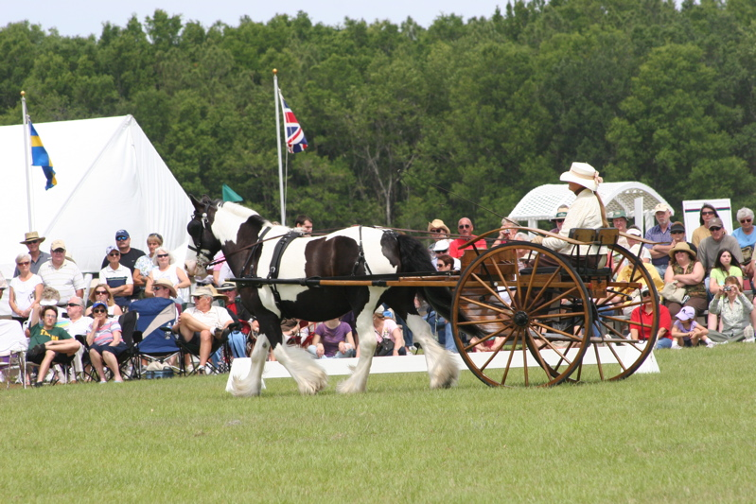

Florida Horse Park- Festival of the Horse
April 16,2009

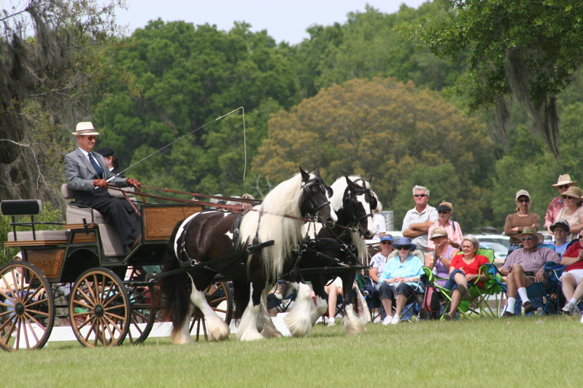

Florida Horse Park- Festival of the Horse
April 16,2009

